

Organizational Behavior

Course Summary

Marc Delingat

delingat@yahoo.com
http://www.geocities.com/delingat

Table of Contents
Table of Contents 2
Study Hints 4
Course Summary 4
Module 1: The Basics of Organizational Behavior and its Relation to Management 4
Managers’ role in organizations 4
Employees values and personalities 5
Job Satisfaction 7
Organizational Commitment and Job Involvement 9
Module 2: Stress and Well-Being at Work 10
Module 3: Contemporary Theories of Motivation 12
Content Theories of Motivation 12
Process Theories of Motivation 13
Behavior Modification 14
Module 4: Organizational Control and Reward Systems 17
Performance Measurement 17
MBO 19
Rewards and Reward Systems 20
Executive Compensation 21
Company Pay Practices 21
Individual and Group Based-Rewards Systems 22
Module 5: Job Design and Employee Reactions to Work 24
Why job design? 24
Job Design Principles 26
Self-directed teams 27
Empowerment 28
Participation 28
Module 6: Understanding Work Group Dynamics and Group-Based Problem Solving 29
Group Structure and Definition 29
Group Dynamics 33
Brainstorming, Nominal Group Technique, Delphi Technique 33
Maintenance and Task Activities 34
Intergroup Behavior Management and Performance 35
Social Loafing 36
Deciding upon the extend of participation in decision making 36
Group Conflict Management 37
Module 7: The Influence Processes in Organizations: Power, Politics, Leadership and Entrepreneurship 38
Types of power and how to obtain it 38
Politics 40
Managing your manager 40
Management and Leadership 41
Entrepreneurship 44
Module 8: Organizational Design and New Forms of Service-Driven Organizations 46
Organizational Design 46
Coordination and Control 50
Responsiveness 51
Customer Service 52
Module 9: Managing Transitions: Organizational Culture and Change 55
Organizational Culture 55
Why do Organizations Change? 56
Organizational Change Process 59
Change Methods 61
Thanks and Revision History 64

Study Hints
The following study hints came from the watercooler and are attributed to Professor Dailey:
- Be sure to understand the content and process theories of individual motivation and how they predict performance.
- As you study OB concepts, always ask yourself how you would apply each one to solve a problem if a firm.
- Emphasize work system design in your studies (Herzberg and JCM)
- Pay close attention to group behavior as a knowledge pathway to making improvements in how self-directed teams can be put to work to strengthen competitive advantage.
- Incentives, incentives, incentives for executives; teams, work units and individuals (don't forget to stress Lincoln Electric, Scanlon and Rucker in there too)
- Leadership and its importance for strategic direction, competitive advantage and proper board-CEO relations in the post-Enron-WorldCom world.
- Service quality as a solid component of strengthened competitive advantage
- Recognizing the need for, guiding and measuring the results of organizational change.

Obviously any other topic not mentioned here can also be subject of an exam.

Course Summary

Module 1: The Basics of Organizational Behavior and its Relation to Management

Organizational Behavior is the study of behavior and attitudes of people in organizations.

Managers’ role in organizations
Management is a process which is employed by individuals (managers) who are responsible for achieving organizational objectives through people. A manager’s job has three basic components:
- Technical: Efficient use of resources to achieve output goals and the application of technology to achieve productivity goals
- Conceptual: Development of new systems and methods of operation.
- Human: Concern with employee welfare

As a manager grows in the organization the technical responsibilities diminish while the conceptual and human aspects take more and more time.

Surveys have shown the following seven key features of a managers’ job:
- Managing individual performance (supervising)
- Instructing subordinates (teaching and training)
- Represent one’s staff (representation and advocacy)
- Managing group performance (facilitation)
- Planning and allocating resources (decision-making)
- Coordinating independent groups (collaboration)
- Monitoring the business environment (scanning)

Managers’ challenges in the 21st century
 | Past Challenges | Future Challenges
Principle duties | Give orders to subordinates and control their behavior | Encourage the development of subordinates and their work teams
Training and Development | Reduce these costs by hiring workers with requisite skills | Training and employee development are continuous to achieve the goal of a flexible and cross-trained workforce
Reward bases | Seniority, rank and effort | Merit-based individual and team contributions to competitive advantage
Influence base | Hierarchical position | Technical, interpersonal, and organizational expertise
Communication pattern and style | From the top to the bottom in highly formal teams | Diffusion-based so that the information goes rapidly to where the decision has to be made
Decision-taking style | Superior/boss centered and authoritarian | Team-based and participative
Approach to organizational change | Resist change and cling to the status quo | Embrace change and find ways to improve strategic, competitive process

Employees values and personalities

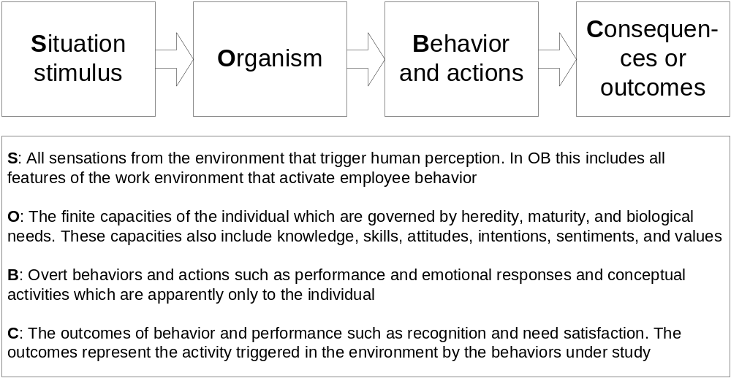
SOBC model of employee behavior in organizations (micro-level)

Instrumental values are the means to achieve goals by using acceptable behavior to achieve an end state. Examples are: Ambition, Competence, Cleanliness, Courage, Self-control, Forgiving Nature, etc.
Terminal values are the goals to be achieved or the appropriateness of a desired end state. Examples are: Achievement, Social status, Wisdom, Equality, Happiness, Inner Calm, Pleasure, etc.

The locust of control is defined as individual’s belief that one’s action influence to outcomes one experiences in life. Internalizers believe that they can change the outcome of experiences through their behavior. Externalizers believe that the outcome of experiences lies outside of their control.

Extroversion is defined as the need to obtain as much social stimulation as possible from the environment. Introversion is defined as avoidance of external stimulation in favor of internally oriented, contemplative activity.

Machiavellian personalities (‘High Machs’) have generally the following characteristics:
- Attempt more interpersonal manipulations
- Are more inventive in manipulating others
- Conceive more manipulations to choose from
- Experience more satisfaction from successful manipulations than others

Socially acquired needs are defined as:
Need for Achievement is defined by the following qualities:
- Taking moderate risks by pursuing goals that are difficult but not impossible
- Needing immediate feedback on performance and progress
- Finding task activities and accomplishments to be intrinsically rewarding, regardless of the financial or economic reward
- Defining work in terms of approaching success instead of avoiding failure
- Being totally task absorbed until the job is done
Managers can use information about the need for achievement as follows:
- Use need for achievement as one basis for screening job applicants
- Use it as a factor in promotion decisions
- Design jobs with goals that are at least moderately challenging
- Design rewards and feedback that are closely tied to performance behaviors to create an achievement climate in the firm
- Reward employee creativity and institutionalize the role of ‘idea champions’ in the firm

Need for Affiliation is defined by the following qualities:
- Positive reaction to experiences that enhance belongingness, social involvement, and group morale
- Emphasizing that all group members are included in events that may affect the morale and cohesion of the group
- Solving or confronting interpersonal conflicts which threaten the esprit de corps
- Emphasizing the importance of social rewards such as recognition, praise, and public acclaim
- Reacting positively to social rewards which are made contingent on excellent performance
Managers can use information about the need for affiliation as follows:
- Allow individuals to be arbitrators in work-group disputes because they will take a personal interest in restoring harmony
- Evaluate the social demands of a job and match employees with high need for affiliation to those jobs
- Allow individuals to be involved in community affairs which parallel work interests
- Develop and use as many forms of social rewards as possible and render them dependent on high performance
- Realize that a superior with a high need for affiliation may incorrectly emphasize social harmony over productivity

Need for Power is defined by behaviors oriented towards influencing others and searching for opportunities to gain influence and control.
Personalized need for power is often unproductive because those individuals:
- Reject job responsibilities in favor of personal concerns
- Create tense work relationships among subordinates who become over-anxious
- Are poorly adjusted to work and frequently look to palliatives such as drugs or alcohol to cope with stress
- Project their own inadequacies on to others and thus eroding the work climate even further
Individuals with a socialized need for power tend to achieve personal goals at work through raising the self-esteem of subordinates and colleagues.
Managers can use information about the need for power as follows
- Employees with a socialized need for power should be selected and promoted over employees oriented to personalized power
- Positions requiring socialized power should be made visible in the organizational hierarchy
- Managers with socialized power should take charge of groups where performance and morale is low
- Social power managers should be allowed to freely delegate to subordinates whose own managerial skills and self-confidence will develop more quickly
- Social power managers’ career paths should not be blocked. If they are unable to obtain the personal rewards they may resort to other, less desirable personalized methods.
If a manager with a high need for achievement should does not also have a socialized need for power she will tend to do things herself, rather than delegating, and ultimately might loose subordinates that share the high sense of achievement.

Job Satisfaction
Job satisfaction is determined by the following attitudes:
- Satisfaction with the work itself
- Satisfaction with pay
- Satisfaction with follow workers
- Satisfaction with supervision
- Satisfaction with promotions

Determinants of job satisfaction:

- Years in Career
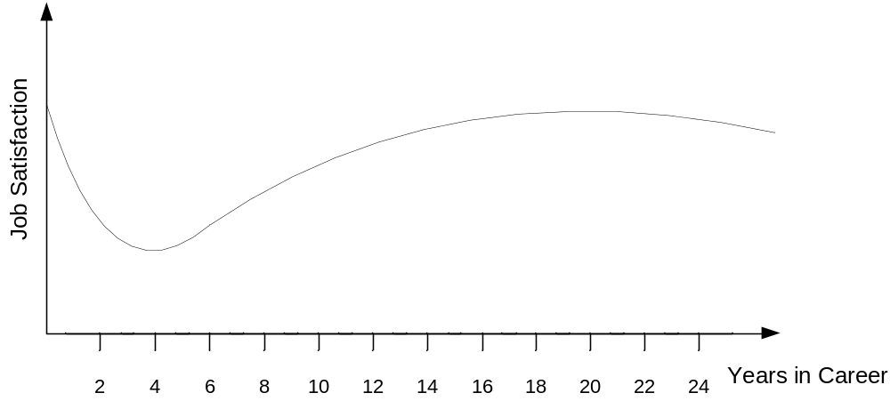
- Expectations: The expectations regarding the job that are formed before the job is started are a major determining factor of the job satisfaction in the first few years. Internships and job previews can help to set realistic expectations.

Organizational determinants of job satisfaction:
  - Supervision: support of self esteem and self worth, consultation with employees
  - Job challenge: design jobs to require creativity, application of personal skills, and risk taking
  - Job clarity: understanding of what they are to do, performance feedback, chance to participate in job issues
  - Incentives: Extrinsic (pay rise, promotion, praise, status symbols) and intrinsic (experienced internally, e.g. feeling of competence, craftsmanship) rewards
Equity Theory: employees make comparisons about the rewards that they receive relative to their efforts and performance levels. Further they make these comparisons relative to rewards, efforts and performance exhibited by other employees.

Consequences of job satisfaction:
- Mental and physical health increase
- Lower turnover
- Less unexcused absences

Job Satisfaction and Performance

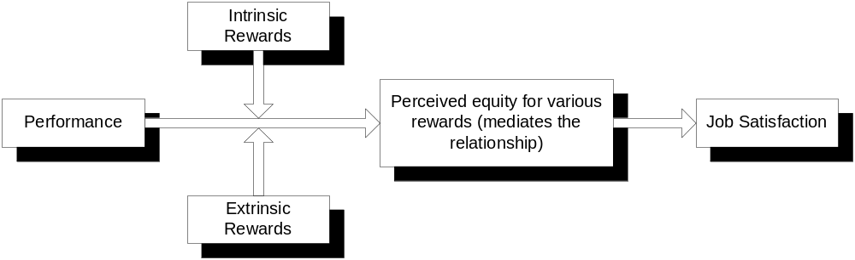

Satisfactory performance triggers the release of several extrinsic and intrinsic rewards. If both reward systems are designed right they trigger perceived equity. This in turn is one contributor to job satisfaction.

Job satisfaction can be determined through the following three methods:
- Observation of employee behavior
- Interviewing employees
- Questionnaires on job satisfaction

Organizational Commitment and Job Involvement
Organizational commitment is defines as the strength of an employee’s identification with the organization. It has the following components:
- Belief in and acceptance of the organization’s goals
- Willingness to exert considerable effort on behalf of the organization
- Desire to maintain membership in the organization
Job satisfaction might fluctuate considerably over time while organizational commitment develops slowly and consistently over time. Employees with high organizational commitment are unlikely to leave their jobs even in a period of low job satisfaction.

Job involvement is a work attitude that is defined as the degree to which employees identify with their job, participate actively in it and consider it a key determinant of their self-worth.

How can managers raise organizational commitment and job involvement?
- Demonstrate that they honestly care about their employees’ welfare
- Create opportunities for employees to achieve their personal goals
- Modify jobs so employees have more opportunities to achieve intrinsic rewards
- Find ways to reward employees regularly
- Set goals with employees and be sure that some of them are personal development goals which are meaningful to the employee in question

Module 2: Stress and Well-Being at Work

Stress results in employees:
- making more physical and mental health claims,
- being less productive
- exhibiting more turnover absenteeism, and substance abuse

Karoshi is sudden death by heart attack or stroke caused by too much work.

General Adaptation Syndrome
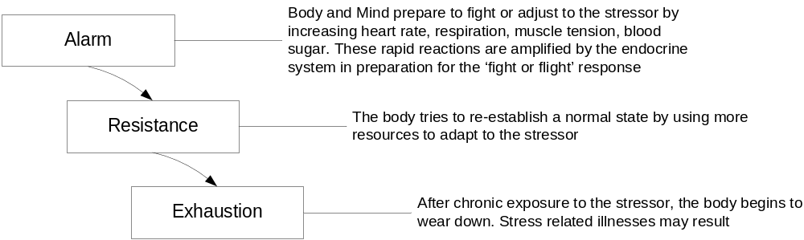

Eustress is a positive mental or physical reaction to stress. Distress is the dysfunctional result of stress. When we experience eustress it is a reflection of our successful adaptation to stress in the work setting or it represents a degree of stress that does not exceed our personal capacity to cope with stress.

Stress Model
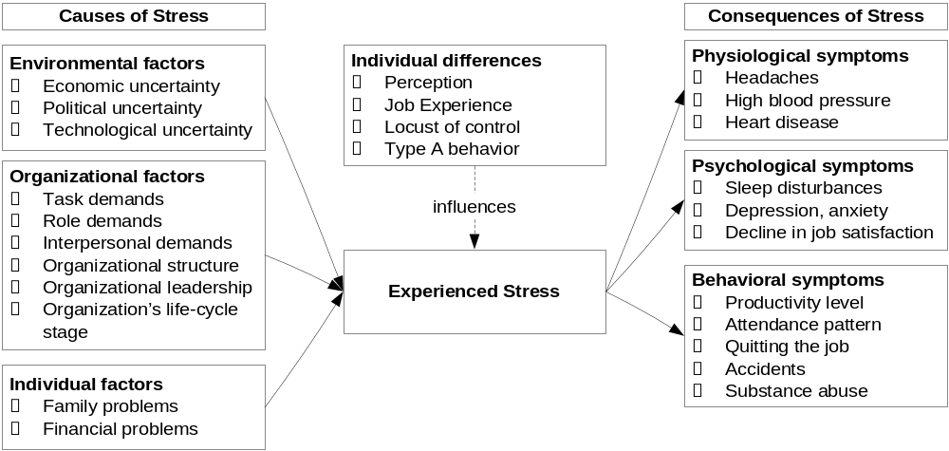

Type A and Type B behavioral patterns

Type A | Type B
Measures success by quantity of results  Is always active and moving  Walks, talks, and eats rapidly  Does two or more things at once  Can not cope well with leisure time  Is obsessed with numbers and measures of performance  Is socially aggressive  Is highly competitive  Experiences constant time pressure | Is mild-mannered  Relaxes without guilt  Is not concerned about time  Is patient  Does not brag  Plays for fun, not to win  Has no pressing deadlines  Is never rushed

The Stress-Job performance relationship

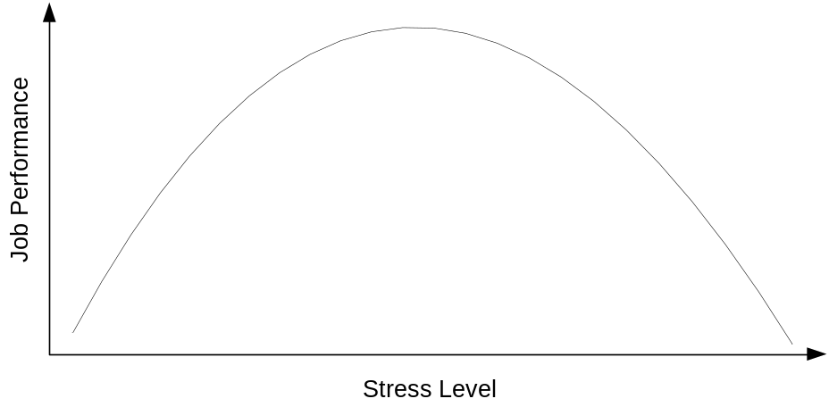
Individual approaches to managing stress:
- Exercise
- Relaxation (mediation/prayer invoke the relaxation reaction that reverses the stress reaction)
- Diet (high sugar food stimulates or prolongs the stress response)
- Opening up (confide in others)
- Professional help

Organizational programs and management skills for wellness and job stress management:
- Reward by performance and productivity, not ‘face-time’ spent working
- Live by your values and encourage others to live by theirs
- Build respect based on trust and respect

Module 3: Contemporary Theories of Motivation

Content Theories of Motivation

Maslow’s Hierarchy
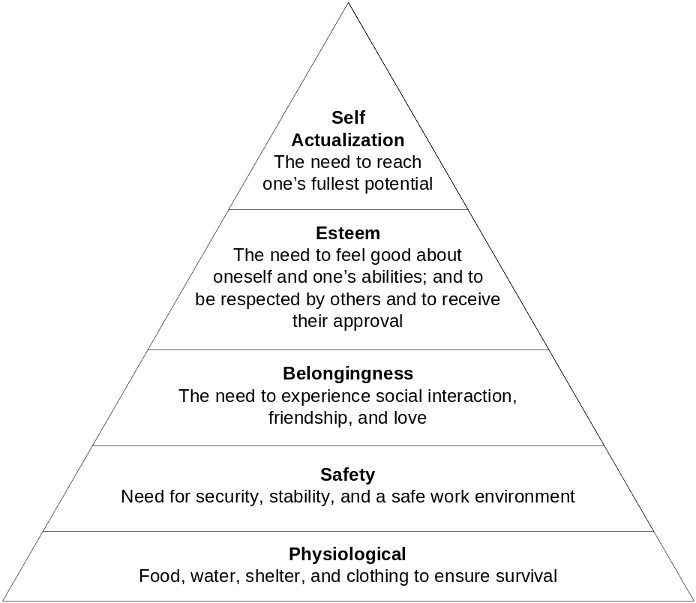

Additional notes:
- A satisfied need ceases to motivate behavior at that need level.
- Unsatisfied employee needs lead to undesirable outcomes at work. Unsatisfied needs create perceived inequity for employees. When this condition persists employee’s job satisfaction decreases.
- People are assumed to have a need to grow and move up the need hierarchy. All humans self-actualize in some way, however not everyone does it at work.
- Needs are not usually satisfied completely. Individuals usually can satisfy more, lower order needs than higher order. In organizations the lower order needs are generally satisfied with money, the higher order ones by social interactions and the design of meaningful jobs.
- Unless physiological needs are satisfied, higher order needs cannot come into play.
- As employees move through their careers , their needs pattern shifts to higher order needs

Herzberg’s Two-Factor (or Motivator-Hygiene) Theory of Motivation

Hygienes are contextual factors that, if not present, lead to the impoverishment of the employee’s job. Employees experience job frustration and stress if their jobs have few hygienes. Employees might experience short increases in job satisfaction hygiene factors are improved, but will take them for granted again after a relatively short period of time. If hygienes are removed job satisfaction plunges.
Motivators are factors that raise job satisfaction and performance in the long run. They are related to the employee-job interaction and are job-centered characteristics.

Herzberg is concerned with job and organizational sources of job satisfaction and dissatisfaction. Maslow focuses on human needs which encompass a variety of life situations, one of which is work. Herzberg’s model is a specific application of Maslow’s hierarchy to work.

Process Theories of Motivation

Equity Theory
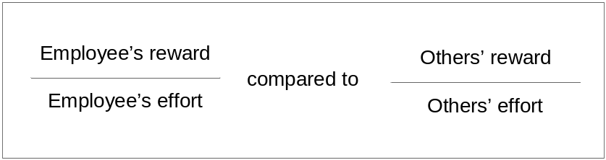

Felt or perceived inequality in this relationship is a motivating state which encourages the employee to eliminate it by pursuing various actions. Negative inequity is perceived when the employee feels that he receives relatively fewer rewards for his effort that others. Positive inequity is perceived when an employee feels that he receives relatively more rewards for his efforts that others.
To restore equity an employee might:
- Change work inputs and reduce performance efforts to eliminate negative inequity
- Change the outcomes received (e.g. ask for more responsibility to reduce positive inequity)
- Exit the circumstance (e.g. leave job)
- Change the people that are used for comparison
- Mentally distort or alter the comparison
- Take a decision to alter the inputs or outcomes of the comparison ‘other’ (e.g. get the other to work less hard)
The following guidelines can help a manager to keep these principles in mind when managing employees:
- When very important or valued rewards are allocated, employees who are equity sensitive are most likely to make equity comparisons which are based on traditional rewards available in the work setting
- In making reward allocation decisions, anticipate that certain employees will feel both, positive and negative equity (entitleds and benevolents).
- In advance tell employees about salary ranges, pay increases, and promotion opportunities.
- Avoid practices that encourage secrecy about pay policies and procedures. While it may not be advisable to encourage pay comparisons directly, employees should fully understand the pay ranges, brackets, and the relationship between excellent performance and values reward (instrumentality).

Expectancy Theory
Behavior is always purposeful and goal directed. Behavior must be understood in terms of the probabilities that a certain behavior will lead to outcomes valued by the individual.

Valence is defined as the personal attractiveness of different outcomes. If an outcome has a high personal valence, an individual is attracted to behaviors that make that outcome more likely.

First-level outcomes are results of expending effort in some way (e.g. job performance, leaving a position) and are important for organizations. Second-level outcomes are the result of achieving (or not achieving) the first level outcomes (e.g. getting a promotion, receiving recognition). Employees assign valence to each type of outcome.

Instrumentality is the personal believe that first-level outcomes lead to second-level outcomes.

Expectancy is the subjective belief that a given level of effort will lead to a first level outcome on the job. Expectancies are judgments about the relationships between certain levels of effort and the various first level outcomes.

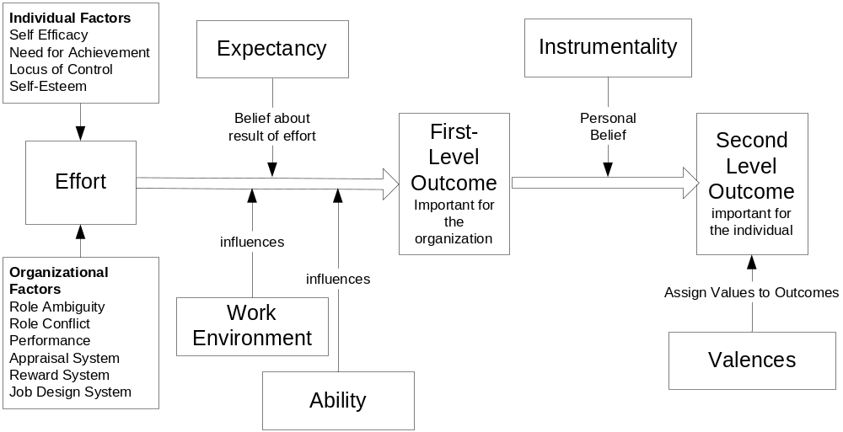

Behavior Modification

Behavior Modification (B Mod) states that behavior is a function of its consequences.

Concept/Term | Definition
Operand Conditioning | Reinforcement which modifies behavior of an operand through it’s consequences
Law of effect | Tendency of an individual (operand) to repeat behaviors that cause favorable consequences and not to repeat behaviors that cause unfavorable consequences
Positive/negative reinforcers | Favorable/unfavorable or pleasant/unpleasant consequences
Positive reinforcement | Strengthening a behavior by occurrence of a positive consequence
Negative reinforcement | Strengthening a behavior by removing an unpleasant consequence
Punishment | Weakening a behavior by occurrence of an unpleasant consequence
Extinction | Weakening a behavior with the occurrence of a neutral consequence or removal of a positive consequence
Behavioral shaping | Structuring of reinforcements, punishment, and extinction to achieve successively closer and closer approximations of the desired behavior
Schedule of reinforcements | Frequencies with which reinforcements accompanies behaviors
Stretching the ratio | Lowering the rate of reinforcements accompanying the behavior

Schedules of Reinforcement
Schedule | Description
Continuous | Consequence follows directly after each response
Partial | Consequence does not follow every response
Partial reinforcement schedules
Fixed ratio (FR) | A fixed number of behaviors must occur before reinforcement occurs
Variable Ratio (VR) | A variable number of behaviors (around some average number) must occur before reinforcement
Fixed Interval (FI) | After a given amount of time has elapsed, reinforcement occurs
Variable Interval (VI) | After a variable amount of time (varying around some average time) has elapsed, reinforcement occurs.

The ratio or interval of reinforcements should only be stretched to make sure that employees do not take the reinforcement for granted. It should not be used as a form to save on rewards. Also, financial rewards should not be stretched as that will result in an increase in distrust of the management.

Pros and Cons of B Mod
Supporters believe | Opponents believe
- It focuses on observable behavior instead of intangible individual differences  - No manipulation occurs when employees participate in the behavior modification  - It improves employees instrumentalities  - Employees receive higher quality feedback about their performance | - It undermines employees respect and dignity  - It makes organizations more manipulative and exploitative  - It makes employees dull an de-humanized extensions of the machines that they operate  - It oversimplifies work behavior and erodes employee creativity
Managers do not like to talk about punishment because it implies that:
- they have hired the wrong employee
- the work environment they help create is less than ideal
- they and their organization treat their employees badly

Reasons for not using punishment:
- For it to be effective managers must closely watch employee’s behavior
- Punishment does not eliminate unwanted behavior, but just suppresses it temporarily until the punisher is removed.
- Employees become anxious, fearful, less creative, hostile and may reject delegated responsibility

Alternatives to using punishment:
- Use of Extinction
- Re-engineer the work environment so that undesirable behavior can not occur
- Reward behavior which is physically incompatible with undesired behavior (e.g. reward employees for tidy workplaces)
- Be patient and allow time for undesirable behavior to disappear

Our natural environment teaches us new behavior through punishment (staying too long in the sun) without permanent emotional damage. In organizations natural punishers are e.g. machinery of all kind, customers, etc. For some behaviors punishment might be the only logical alternative. This will e.g. be the case when the employee pursues activities for his own pleasure, such as drug or alcohol abuse.

If punishment is used it should be:
Rapid: Undesirable behavior must be prevented from becoming a habit of the employee
Intense: Punishment should be intense and immediate, leaving no question about the undesirability of the behavior
Equitable: Punishment must be equitable across people and infractions. Match the punishment to the infraction
Informative: Punishment must have informative value: information on why behavior is undesirable, how to correct behavior, consequences of further infractions
Private and focused: The employee’s self-esteem should remain intact. He should remember the behavior to correct instead of how he was mistreated.
Not followed by rewards: Punishment should not be followed by non-contingent rewards (e.g. lunch to alleviate the supervisor’s guilt)

Conditions that should be met before installing a B Mod program:
- Moderate to high trust between employees affected and their supervisors exists.
- Employee must believe that good workplace hygiene exists.
- Employee must have control over pace of work (i.e. no machine paced work).
- Employee ability can not be the cause of the problem.
- Employees understand successful performance behaviors that they can measure and record.
- Employees must get regular feedback about their progress towards performance goals
- Supervisors must be trained and committed to the B Mod program so that they understand the underlying principles

Steps to setting up a B Mod program:
- Conduct a job analysis to ensure understanding of job responsibilities
- Define performance behaviors and set performance goals
- Conduct a baseline audit to identify the rate of correct performance
- Select powerful and abundant reinforcers to reward excellent performance
- Use continuous reinforcement to encourage new performance behaviors
- Practice behavioral shaping to obtain closer and close approximations to the desired behaviors
- Establish desired behaviors by adding new positive reinforcers which employees value
- Review and evaluate the program to identify and measure target goals such as cost reduction, employee attendance, safety and improved productivity.

Module 4: Organizational Control and Reward Systems

Performance Measurement
Why organizations need to assess performance?
- Employees need to understand the behavior requirements of the job.
- Employee’s work is evaluated for its contribution to company goals.
- Employees receive feedback on their contribution to company goals.
- Employees’ motivation is increased by the performance appraisal system.
- Employees’ performance levels should be used to make decisions about salaries, promotions, bonuses, training needs, etc.
- Employees get clear feedback on the level of performance expectations from the company

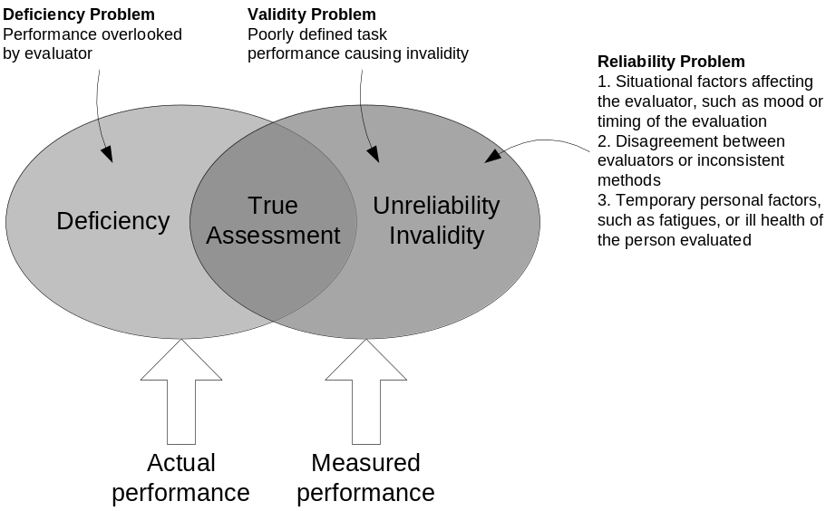

Validity is the quality of the measuring components of the performance appraisal system (do they measure what they should?). Consistency, that is two or more ways to gather performance data producing results which agree, and stability, the property of dependability of results over time, are key attributes of a successful performance appraisal system.

Errors in performance appraisals:
- Personal bias: a stereotype or bias which influences a supervisor’s rating upward of downward.
- Halo effect: rating an employee on one performance dimension based on the evaluation in other performance dimensions
- Recency Error: the emphasis on recent performance examples in making performance assessments
- Central tendency error: Assigning average ratings to all employees resulting in little variation
- Strictness or leniency errors: Supervisor’s ratings based on the belief the employees do not measure up or that all employees measure up
- Similarity error: the supervisor has a performance quality in himself that she is looking for in the employees
- Forcing the rating to match other criteria: Deciding on an overall rating first and then going back to individual dimensions to adjust ratings to match overall assessment

Forms of validity:
- Content validity: measures and their administration are logically related to the performance measured; evaluator and employees agree on the dimensions of performance measured and relationship to actual job behaviors.
- Empirical validity: measures are statistically related to work outcomes. Scores on the performance dimensions are related to quantitative measures of work output
- Construct validity: performance appraisal system logically derives from a model or theory of performance behavior and motivation.
- Convergent validity: Multiple measures of the same performance dimension result in equivalent scores. Observation methods correlate highly with paper and pencil measures of performance.
- Disciminant validity: Measures of performance using the same method produce different scores for different performance

How to overcome errors in performance appraisal systems:
- Use multiple criteria
- Emphasize behavior rather than traits
- Use several raters (e.g. 360 degree reviews)
- Train the raters

Performance Appraisal Methods:
- Absolute Standards: Each employee is judged against a fixed and inflexible set of performance criteria. Often results in upward biased ratings due to leniency error and validity error due to the simple ‘meets/does not meet’ nature of the assessment on the standards.
- Graphic Scales Rating System: List of performance criteria are evaluated on a numerical scale. The ratings highlight differences in the performance of subordinates as it encourages the tendency to spread out employee’s assessment across each scale. Inaccuracies due to strictness, leniency or similarity are still possible. Forced distribution across the full scale might lead to (perceived) unfair evaluations.
- Behavior Anchored Rating Scale (BARS): BARS emphasizes work behavior and how the work gets done rather than characteristics of an employee. Through a participatory analysis a meaningful and agreed upon set of behavioral anchors described in the language of the job under evaluation are developed. The clarity of the behaviors improves employees’ understanding of the job and performance expectations. The strong behavioral focus of the BARS system:
  - might help to avoid the evaluation of irrelevant employee’s personality traits
  - might increase the quality of the feedback compared to other systems
  - might enhance the significance of the feedback in the employee’s minds through reduced defensiveness
  - might require a long time to develop as different roles will require different BARS
  - might be difficult to develop for jobs requiring creativity, curiosity, and complex problem-solving.

MBO
Goals are defined as those end states that reduce the intensity of needs and motives. Goal setting systems:
- Increase motivation and performance
- Reduce the stress of conflicting or confusing expectations
- Improve accuracy and validity of performance evaluations

The goal setting process model:

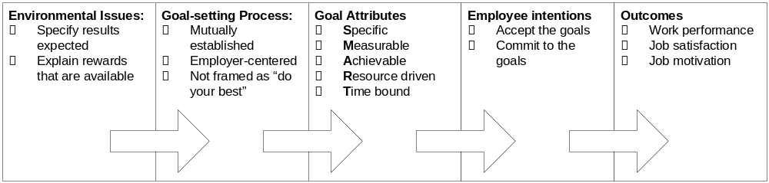

The seven generic steps of a MBO program:
- ANALYZE the mix of people, jobs, work methods, and external demands
- PLAN goals, strategy, communication and training
- DEFINE the employees’ job in terms of content, authority, and responsibility
- ARTICULATE goal difficulty, clarity, number, feedback
- Reach MUTUAL AGREEMENT about goals, work methods, goal measurements, and time frame
- Make INFORMAL review of goal achievement, methods and probable rewards, and REVISION of goals and methods if necessary
- Make FORMAL review of goal achievement and rewards to be obtained

MBO must be managed and refined over time. Managerial vigilance ensures that the MBO system remains meaningful to employees. The following items help to preserve the quality of an MBO system:
- Top management support, commitment, and involvement before and during the program
- The MBO system must have a strong relationship with routine activities and responsibilities. The company’s basic technology, products, and/or services have to be strengthened by the MBA system.
- MBO must emphasize organizational and personal development goals and thus aid in achieving higher-order need satisfaction.
- Personnel must be properly trained to administer and function under the MBO system.
- MBO must be tailored to the needs of the different departments
- Managers must avoid overemphasis on number of goals and how quantified they are. Keep the 80-20 rule in mind. Sticking with this rule prevents the definition of too many and too narrow goals
- The MBO benefit must far exceed the cost (e.g. paperwork) of the program
- Equal emphasis should be placed on discussion and evaluation. Too much discussion leads to uninspired goals. Too much evaluation leads to perceptions of manipulation and over-control.
- MBO works best when goals can be flexible and adjusted to unforeseen circumstances.

Rewards and Reward Systems
Rewards strongly influence employee effort and performance levels. How the rewards are perceived can easily outweigh the rewards actually distributed by the company. If employees see a weak link between performance and rewards (expectancy theory), the reward ceases to function as a motivator.
Intrinsic rewards are defined as those rewards that the employee associates with the job itself. Extrinsic rewards are given to the employee by the company and they do not occur as the work unfolds. Extrinsic rewards can be classified as direct compensation, indirect compensation, and non-financial rewards.
There is great motivational value in building as many intrinsic rewards in to the job as possible. Employees will value goal setting more if they know that participation will lead to intrinsic and extrinsic rewards.
How do companies distribute direct compensation?
- Performance
- Effort (in the hope that effort will eventually lead to performance)
- Seniority
- Equality (common in partnerships for managing partners)
- Power and Influence

What determines the value of a job to the company? A job classification system in which jobs are ranked against each other the following factors determine starting salary, pay grade, and the number of levels in a given pay grade:
- Skill requirements
- Mental requirement
- Physical requirement
- Responsibility
- Working Conditions

Executive Compensation
Basic components of Executive Compensation:
- Base salary
- Benefits
- Long-term incentives
- Annual bonus

Current trends in executive compensation:
- Strengthening the link between executive compensation and the market value of firms
- Executive compensation rises faster than employee wages
- CEO pay rises much faster that the pay of the second in command
- Pay gaps between American and British executives narrow
- More emphasis on the company’s net income
- Preventing ISO plans from diluting stock value

Company Pay Practices
Reward Practice | Employee perspective | Implementation issue
Cafeteria style fringe benefits | Creates balance between family needs and benefits package | Installation cost and administration are increasingly outsourced
Lump-sum payments | Nice to earn a large bonus but might not be clear what he/she did to earn it. | Likely to be abandoned during downturns, can upset shareholders
Skill-based compensation | Good incentive for learning new skills | Works if skills are measurable, documented and verified. Should not be tied to external educational or management training program achievements
Accumulating time-off | Helps family, work, child, and elder care demands on employees | Strengthens commitment and loyalty. Harder to implement in self-directed teams.
The all-salaried team | Workable if team performance is fairly measured and teams are empowered | Easier to implement if union influence is declining. Validity of team appraisal system must be high.
Open salary information | Greater perceived pay equity and job satisfaction with work and supervision | Computer based and outsourced control systems make implementation easy. Requires stable pay brackets and market based, fair starting salaries.

Any pay or incentive plan should pass the following five tests:
- Does the plan capture the attention of the employees?
- Do employees understand the elements of the plan?
- Does the plan improve communication?
- Does the plan make payments to the employees when it should?
- Is the company performing better as a result of the plan?

The following guidelines can be used to improve the performance and effectiveness of the company incentive plan:
- Tie incentives in the reward system as closely as possible to actual performance on the job.
- To the extend possible, the incentive system and benefits program should be adjusted for individual differences of employees in the workforce.
- Incentive programs should match the type of work performed by the employees and the structure of the firm.
- The pay system should be consistent with the culture of the firm.
- An incentive system should be monitored over time to ensure that employees are being paid at the prevailing salary level for their work, that they are treated fairly and the program is properly administered.

Individual and Group Based-Rewards Systems
Gain-sharing plans (also called Scanlon Plans) share the gains associated with cost savings between the employer and the owner of the company. Scanlon plans use production and steering committees to screen and evaluate the suggested productivity enhancements. These programs are powerful tools to lower costs and foster innovation at the level at which the work is done. They also increase employee satisfaction and turnover. Important points to remember about gain sharing programs are:
- They work best if the company has a dependable history of labor cost. If there is good accounting data on labor and production cost, the formula to calculate the gain sharing percentage can easily be established.
- Seasonal product demand might make gain sharing plans more difficult
- The market might have to absorb additional production if the gains lead to higher output.
- The company should have a trusted labor-management relationship in order to develop trusted gain sharing formulae.
- Production units of 30-500 people work well. Larger units might need several gain sharing plans joined by a common accounting system.
- Management needs to be committed to the plan and train all employees on the operation of the system

A well designed team based rewards system can strengthen an organization in the following ways:
- Attraction of new skilled employees and retention of existing ones
- Timely and attractive incentives increase employee’s motivation and performance
- If rewards are tied to cross-training and skill-building, the team members will acquire the necessary skills and make the workforce of the company more flexible and gain a competitive advantage.
- Linking incentives to corporate values creates an organizational culture that competitors will have a hard time copying.
- Reinforcement and definition of structure. E.g. usage of stock option incentives for every employee in a de-layered organization.
- Since cost is to a large extend driven by incentives, the structure of incentives needs to be driven by the company’s strategic advantages.

In a Rucker Plan, the measurement of productivity used for incentives is called value added. Value added is the difference between sales income from goods produced and the cost of the materials, supplies, and outside services consumed in the production and delivery of that output. Payroll costs are all employment costs related to the employee group measured. To establish a Rucker plan, the following steps can be followed:
- Identify a base period that will provide valid and useful data to establish a standard based on typical operation of the team.
- Generate the following data:
  - Sales Value of Production (SVP)
  - Cost of Materials, Supplies, services, etc. (COM)
  - Cost of Labor (COL)
- Using this data establish the following standards:
  - Value added (VA) = SVP – COM
  - Labor Contribution to VA (LCVA) = COL/VA
  - Economic Productivity Index (EPI) = 1/LCVA
  - Expected Value of Production (EVP) = EPI x COL (for the bonus period)
- At the end of the bonus period calculate the result
  - Actual Value of Production (AVP) = SVP – (COM + COL)
  - Savings or Loss = EVP – AVP
  - Money placed in bonus pool = LCVA x Savings or Loss

In a Rucker plan 75% of the bonus is paid monthly to employees and the remaining 25% is held in an escrow account until the year’s end. This money is used as a cushion for periods when self-directed teams pail to meet their standard. After a year end audit the remaining funds are distributed.

Comparison of characteristics of a Rucker and a Scanlon Plan:
- Rucker plan links profit in terms of value added to labor’s contribution.
- Employees that understand the Rucker plan will have ideas for raising labor’s value added. Thus problem solving in the team is stressed.
- The Rucker plan is less rigid than the Scanlon plan in the requirements for participation (e.g. no review committees required) and leaves it up to the firm to develop a fitting system of generating value added suggestions.
- Lower level of hierarchical control in the Rucker plan can shorten time from idea to implementation.

To be successful, a Rucker plan needs to be established in a firm that value’s its workforce and practices empowerment. Effects of downsizing and delayering may traumatize a company’s workforce and postpone or foil entirely the introduction of such a plan.

If a firm has downsized, the following conditions should be met before a gain-sharing or Rucker plan is introduced:
- The firm has returned to profitability and no further wage freezes are planned
- The management tem is stable.
- Self-directed teams are working and members have completed training in TQM, process control, and team building.
- The company is not being positioned for a sale or a spin-off.
- Outsourcing of non-essential functions has been completed
- The firm is using service-driven and market-based measures of customer satisfaction

Profit sharing plans are based on the notion that employees should be able to participate positively if a company is generating a profit. If companies do well, profit sharing plans are popular, in times of reduced profits or even losses, the popularity falls dramatically.

Module 5: Job Design and Employee Reactions to Work

Why job design?
The concept of quality of work life (QWL) refers to the extend to which employees are able to satisfy important personal needs through their work life. This can be achieved through management’s design of more meaningful jobs which enhance job involvement and motivation. In essence QWL programs try to integrate employee’s needs with organizational goals, such as improving competitive advantage. QWL programs must show a positive effect on the bottom line as well as meet the higher order needs of the employees.

Traditionally jobs were designed by managers breaking down work in to elements which were analyzed by number and time necessary to complete them (scientific management). The elements were then assembled in to a job that would be the most optimum way to accomplish the work function. Jobs would be made simple so that the need for employees to think about the job element to complete was minimized. The goal was to maximize economic efficiency of the company. The primary tool of scientific management’s approach to job design were time and motion studies, differential piece-rate pay systems and the scientific selection of workers that possessed traits and abilities that closely matched the requirements of the simplified jobs. The impacts of this way of job design on the workers were as follows:
- Limited social interaction
- Low skill requirements
- Machine pacing
- Job activity repetition
- Task specialization
- Low employee creativity and ingenuity
- Tools and methods are pre-specified

The negative effects of this system of job design are as follows:
- Over-dependency on work rules and standard production rates at the expense of job control by the employee
- Employees often feel isolated from their co-workers
- Craftsmanship, pride in the finished product and product quality is sacrificed for job specialization and productivity

Job enlargement is a method of job design that increases the number of work activities in a job to decrease the extent of boredom and over-specialization.
Job rotation advanced job enlargement by exposing workers to a variety of specialized jobs over time.
Cross-training is a variation of job enlargement; employees are trained in different specialized work activities.
Job enrichment (also referred to as Herzberg’s two-factor theory) proposes that jobs should also include motivational factors. The absence of motivating factors leads to the loss of employee initiative, increased work apathy and the cessation of creativity. However, this does not mean that employees are dissatisfied with their work, but simply that the absence of motivating factors (intrinsic factors, satisfiers) means that employees have no reason to form positive work expectations. Serious decrease in job satisfaction occurs when work hygiene factors (extrinsic factors) are scarce. Hygienes are those factors that maintain a condition of ‘no dissatisfaction’. They include among others:
- Salary
- Job security
- Working conditions
- Status
- Company procedures
- Quality of supervision
- Quality of interpersonal relations

Herzberg’s principles of job design:
- Give employees as much control over the mechanism of task completion as possible.
- Hold employees accountable for their performance.
- Within limits, let employees set their own work pace.
- Design jobs so that employees experience accomplishments.
- Design jobs so that employees lean new skills and work procedures

Employees make conclusions about the presence or absence of job content factors prior to attaining some performance level. Therefore managers can influence job performance by changing job content.

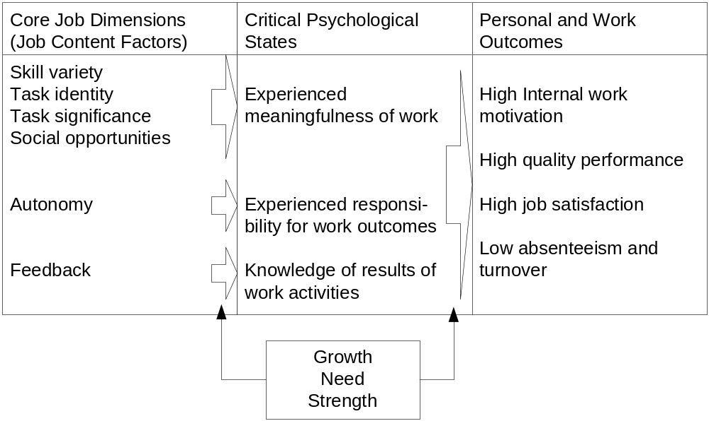

Skill variety: Extend to which the job requires a number of different skills, talents, and abilities to accomplish task activities.
Task identity: Degree to which the job requires doing a complex task from start to finish and experiencing a visible and identifiable outcome.
Task significance: Degree to which to job has a substantial and lasting influence on the lives of employees and other people in the organization and society.
Social opportunities: Extend to which the job allows the employee to have social contact with friends and requires interaction with others to complete work.
Autonomy: Degree to which the job gives the employee personal freedom and discretion to control work activities and schedules.
Feedback from the work itself: Degree to which the job provides direct and complete information on the effectiveness of the employee’s behavior.

When all three critical psychological states are operating, employees are guided by their personal standards of performance excellence and they are fully involved in their jobs. A person’s growth need strength (strength of his need to grow) is a moderating factor. A person with a high growth need strength will be strongly influenced in his performance by having the core job dimensions as part of his job and thereby reaching the critical psychological states.

Job Design Principles
When an employee experiences more control, autonomy, challenge, and direct responsibility over work outcomes, then the job has been vertically loaded or expanded. Vertical loading methods are as follows:
- Employees should be provided with direct feedback on their performance
- Employees should be given an opportunity to learn new skills
- Employees should be able to influence the scheduling of work
- Each job should be given some unique qualities which differentiate it from other jobs
- Employees should have control over job resources
- Personal accountability should be increased

Other trends are four-day work week, job-sharing, telecommuting, and flextime.

Why will interest in job design continue to grow?
- Work design alters the relationship between people and their jobs, greatly expanding the number of available intrinsic rewards
- Job design directly changes behavior since it focuses on what people do instead of what people feel.
- Job design offers opportunities for initiating other changes e.g. create more flexible employee attitudes, foster innovation.
- Job design helps organizations better satisfy employee needs

What problems can occur in job design?
- Technology (technology requires machine pacing)
- Program start-up and maintenance cost
- Failure to consider employee preference
- Managerial and union resistance

Self-directed teams
Socio-technical systems theory integrates two opposing forces in the design of work: the scientific management and productivity emphasis on specialization, and the human needs and interpersonal relations aspects of the behavioral sciences concerned with human development in the workplace.

Autonomous workgroups have to be built to account for the interplay of technical and social work systems:
- The group is assigned a task that is sufficiently identifiable and significant so that the members find the work of the group meaningful
- Each member possesses some skills that are required for the completion of the task and so the flexibility of the group in carrying out the task is increased. If the portfolio of skills is not sufficiently diverse initially, procedures for cross training are developed.
- The group is given sufficient autonomy in making decisions on methods of accomplishment, scheduling, task assignment, and potentially even the selection of new group members.
- Compensation is based on the performance of the group as a whole rather than the contributions of individual members.

Typically the companies setting up self directed work-groups have to consider the following:
  - Creation of high performance norms
  - Minimizing or channeling group conflict to useful ends
  - Creating satisfying interpersonal relations
  - Integrating characteristics of the technical work system in to the structure of the group
Guidelines for designing self directed teams:
- Team should be relatively small (8-20 people) so that group membership is psychologically meaningful
- If teams are to receive training it should be in work skill areas or cross-training. Team centered interventions, such as sensitivity training should be avoided as it may alter the group climate and effectiveness.
- Pay system should be structured so that the individual pay is based on the group performance.
- Role of the manager should switch from vertical liaison with higher management to horizontal integrator of teams.
- Team should have an expanding job range (authority to plan, organize and control work and responsibility for quality and quantity of it’s performance)

A mature self-directed team can be expected to perform the following tasks:
- Evaluate each other using peer reviews
- Cross train each other until all members can do all related jobs assigned to the team
- Schedule work and assignments within the team
- Divide work assignments to fit the needs of team members
- Monitor performance, make corrective changes in process and equipment utilization and report results achieved to higher management
- Apply TQM principles and service quality improvement activities to all phases of the teams work

Empowerment
Empowerment is often an integral part of establishing self directed work teams. The following three prerequisites have to be met in order for empowerment to be effective:
- The capability to become psychologically involved in participative activities.
- The employees have a motivation to act autonomously.
- The capability to see relevance of participation for once well-being.

Participation
Participation in decision making is a core element of job design. From an individual’s standpoint participation has three important features:
- Psychological involvement: when employees are involved in decision making, they are often absorbed in to what they are doing (more higher order needs are satisfied).
- Motivation to contribute: Participation encourages employees to make personal contributions to their organizations. Intrinsic rewards help employees internalize the motivation to contribute.
- Acceptance of authority: When employees experience greater control through participation, they become more willing to accept delegated authority.

Reasons why a company would reasonably avoid empowerment, self-directed teams, and participation which are expensive and time-consuming to install:
- The industry of the firm has high entry barriers or the firm enjoys government protection
- Competition tends to overlook the company because it is too small, or the firm has excellent process and product protection through trademarks, patents and licenses
- Worker productivity gains can be achieved without greatly increasing capital intensity
- The organization already has a lean staffing system with limited management
- Employee’s jobs are specialized and their work is controlled by standard rules and regulations
- Employee’s abilities for problem solving in empowered teams are not sufficient
- Heavily unionized industries might find it hard to redefine jobs
- Participation and empowerment often results in layoffs of middle managers. If the company is growing and middle managers are hard to come by, it might want to keep them around
- Is the new job design system is not linked to a strategic plan, the change becomes a means in itself rather that a means to improve productivity, performance, quality, etc.

